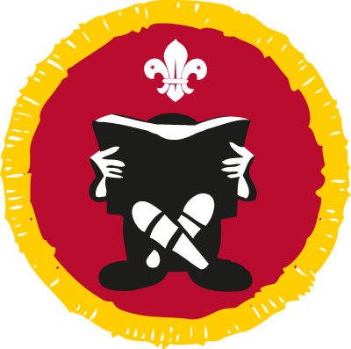
Book Reader Activity Badge
How to earn your badge
- Make a list of at least six books you have read or used recently. Books you have read on an e-reader count too.

- Name the authors of your books. Tell your leader or other Cubs something about three of your books. At least one book should be fiction and one should be non-fiction.

- Show that you know how to care for your books and know the benefits a library can bring to people who enjoy reading.

- Show that you can use a dictionary and a thesaurus.
For example: get them to look up ’Cub’ and ‘Scout’ and find different meanings for each;

- Write a review of your favourite book and share it with your Cub Leader.

Top tips
Completing the Summer Reading Challenge can count towards achieving requirements 1 & 2 of this badge .
For showing that you can use a dictionary or thesaurus, the use of visual/pictorial, verbal, printed or online versions is acceptable.

I confirm that................................................................has met the above stated requirements 3 and 4 for the Book Reader Badge.

Signed..........................................................................

Date ......./......../...........

Please bring this form to a meeting along with the everything you need to complete requirements 1, 2 & 5.

